

A Project Report on

Virtual Traffic Police

Submitted in partial fulfillment of the requirements for the degree of

BACHELOR OF TECHNOLOGY

in

Computer Science and Engineering

by

Nikhileswar R 1660504

P Gayshree 1661052

Kandala Navya Nagesh 1660499

Under the Guidance of

Mrs Mausumi Goswami

Department of Computer Science and Engineering

School of Engineering and Technology, CHRIST (Deemed to be

University),

Kumbalgodu,Bangalore-560 074

April-2020



School of Engineering and Technology

Department of Computer Science and Engineering

# CERTIFICATE

This is to certify that Name 2 has successfully completed the project work entitled “Virtual Traffic Police” in partial fulfillment for the award of Bachelor of Technology in Computer Science and Engineering during the year 2019-2020.

Mrs Mausumi Goswami

|  |  |
| --- | --- |
| Dr. K Balachandran | Dr. Iven Jose |
| Head of Department | Dean |



School of Engineering and Technology

Department of Computer Science and Engineering

# BONAFIDE CERTIFICATE

It is to certify that this project titled ”Virtual Traffic Police” is the bonafide work of

Name

Register Number

|  |  |
| --- | --- |
| Nikhileswar R | 1660504 |
| P Gayshree | 1661052 |
| Kandala Navya Nagesh | 1660499 |
| Examiners [Name and Signature] | Name of the Candidate : |
| 1. | Register Number : |
| 2. | Date of Examination : |

# *Acknowledgement*

We would like to thank CHRIST (Deemed to be University)Vice Chancellor, Dr. Rev. Fr. Abraham V M, Pro Vice Chancellor,Dr. Rev. Fr. Joseph C C, Director of School of Engineering and Technology, Dr. Rev. Fr. Benny Thomas and the Dean Dr. Iven Jose for their kind patronage.

We would like to express my sincere gratitude and appreciation to the Head of Department of Department of Computer Science and Engineering, School of Engineering and Technology Dr. K Balachandran, for giving me this opportunity to take up this project.

We also extremely grateful to my guide, Mrs Mausumi Goswami, who has supported and helped to carry out the project. His constant monitoring and encouragement helped me keep up to the project schedule.

If outside the college-mention the organisation and the concerned people, like head of the organisation, guide and any other person you want to thank. All faculty and nonteaching staff. You may acknowledge your parents or any who supported you.I thank my parents.

# Declaration

We, Hereby declare that the Project titled “Virtual Traffic Police” is a record of original project work undertaken by us for the award of the degree of Bachelor of Technology in Computer Science and Engineering. We have completed this study under the supervision of Mrs Mausumi Goswami, Department of Computer Science and Engineering.

We also declare that this project report has not been submitted for the award of any degree, diploma, associate ship, fellowship or other title anywhere else. It has not been sent for any publication or presentation purpose.

Place: School of Engineering and Technology, CHRIST (Deemed to be University),

Bangalore

Date: April 2020

Name Register Number Signature

Nikhileswar R 1660504

P Gayshree 1661052

Kandala Navya Nagesh 1660499

# *Abstract*

In the evolving world, traffic is being rapidly increasing simultaneously along with the economical development. Not following traffic rules have become a major issue for most of the developing and developed countries. The numbers of vehicles on the road are increasing fast, as well as the numbers of traffic rule violators are raising drastically. Managing traffic rule violations has always been a heavy work as there are lot of people particularly in highly populated country like ours. Even after automating the method of traffic management, it’s really a huge problem, because of the availability to the variety of number plate formats, different scales, frames etc., during image acquisition, poor quality of surveillance video, different weather conditions etc.

In this project, important algorithms namely CNN, Canny Edge Detection and YOLO are used to extract edges from images which is used to find number plates and helmets. Performance factors are analyzed namely accuracy and speed and quality of an image. Accuracy of the results depends upon weather and quality of the image. In the experimental results we found that it is very difficult to capture every image in high resolution in highly populated roads.

The proposed model helps to illustrate a virtual system for detecting and classifying motorcycles on roads using the license plate. The main objective of this project is to control the traffic rule violations accurately and with less cost. The proposed model includes an automated system which uses and camera to capture video. The project presents Automatic Number Plate Recognition (ANPR) techniques and other image detecting techniques for locating the plate and character recognition which makes it faster and simpler to identify the number plates. Background differencing and morphological operations are used to virtually detect motorbikes.Edge detection technique is the another image processing technique. Here the edges of the object is detected; And the other techniques are finding the parameters such as number of motorbikes.

Adaptive background subtractiom is used on video frames to get moving objects. Further, Convolutional Neural Network (CNN) is used on the same to select motorcyclists among the moving obejcts.

Optical Character Recognition(OCR) is a text recognition method used in this project.

OCR helps to translate text on the number plate to machine edible text. After recognizing the alpha numeric number from number plate, the message-based module is used to notify the owners of vehicle about their traffic rule violation.

Contents

CERTIFICATE i

BONAFIDE CERTIFICATE ii

ACKNOWLEDGEMENT iii

DECLARATION iv

ABSTRACT v

LIST OF FIGURES ix

LIST OF TABLES x

GLOSSARY xi

1. INTRODUCTION 1
   1. Problem Identification . . . . . . . . . . . . . . . . . . . . . . . . . . 2
   2. Problem Formulation . . . . . . . . . . . . . . . . . . . . . . . . . . . 3
   3. Problem Statement & Objectives . . . . . . . . . . . . . . . . . . . . . 4
      1. Objectives . . . . . . . . . . . . . . . . . . . . . . . . . . . . . 4
   4. Limitations . . . . . . . . . . . . . . . . . . . . . . . . . . . . . . . . 4
2. RESEARCH METHODOLOGY 5
3. LITERATURE SURVEY AND REVIEW 9
   1. Literature Collection & Segregation . . . . . . . . . . . . . . . . . . . 9
      1. Introduction: . . . . . . . . . . . . . . . . . . . . . . . . . . . 9
   2. Critical Review of Literature . . . . . . . . . . . . . . . . . . . . . . . 13
4. ACTUAL WORK 15
   1. Methodology for the Study . . . . . . . . . . . . . . . . . . . . . . . . 15
      1. Introducing Framework: . . . . . . . . . . . . . . . . . . . . . 15
      2. System Requirements: . . . . . . . . . . . . . . . . . . . . . . 16
   2. Experimental and/or Analytical Work Completed in the Project . . . . . 18

|  |  |
| --- | --- |
| 4.2.1 Python Environment: . . . . . . . . . . . . . . . . . . . . . . . | 18 |
| 4.2.2 Camera Positioning: . . . . . . . . . . . . . . . . . . . . . . . | 19 |
| 4.2.3 Libraries: . . . . . . . . . . . . . . . . . . . . . . . . . . . . . | 20 |
| 4.3 Modeling, Analysis & Design . . . . . . . . . . . . . . . . . . . . . . | 21 |
| 4.3.1 Proposed Architecture: . . . . . . . . . . . . . . . . . . . . . . | 21 |
| 4.3.2 Data Extraction: . . . . . . . . . . . . . . . . . . . . . . . . . | 27 |
| 4.3.3 Data Cleaning: . . . . . . . . . . . . . . . . . . . . . . . . . . | 27 |
| 4.3.4 Data Analysis: . . . . . . . . . . . . . . . . . . . . . . . . . . | 28 |
| 4.3.5 Algorithms and Mathematical Concepts: . . . . . . . . . . . . . | 28 |
| 4.3.5.1 Background Subtraction: . . . . . . . . . . . . . . . | 29 |
| 4.3.5.2 Gray Scale Conversion: . . . . . . . . . . . . . . . . | 30 |
| 4.3.5.3 CNN: . . . . . . . . . . . . . . . . . . . . . . . . . . | 31 |
| 4.3.5.4 Edge Detection: . . . . . . . . . . . . . . . . . . . . | 33 |
| 4.3.5.5 Heuristic Analysis and Priority Selection: . . . . . . | 34 |
| 4.3.5.6 OCR: . . . . . . . . . . . . . . . . . . . . . . . . . . | 35 |
| 4.3.5.7 Feature Extraction: . . . . . . . . . . . . . . . . . . | 36 |
| 4.3.5.8 Character Identification: . . . . . . . . . . . . . . . . | 37 |
| 5 RESULTS, DISCUSSIONS AND CONCLUSIONS | 38 |
| 5.1 Results & Analysis . . . . . . . . . . . . . . . . . . . . . . . . . . . . | 38 |
| 5.2 Epoch-wise results . . . . . . . . . . . . . . . . . . . . . . . . . . . . | 38 |
| 5.3 Comparative Study . . . . . . . . . . . . . . . . . . . . . . . . . . . . | 43 |
| 5.4 Discussions . . . . . . . . . . . . . . . . . . . . . . . . . . . . . . . . | 44 |
| 5.5 Cost Estimation Model . . . . . . . . . . . . . . . . . . . . . . . . . . | 45 |
| 5.6 Conclusions . . . . . . . . . . . . . . . . . . . . . . . . . . . . . . . . | 46 |
| 5.7 Scope for Future Work . . . . . . . . . . . . . . . . . . . . . . . . . . | 47 |
| BIBLIOGRAPHY | 48 |
| A Program Inclusion | 50 |
| A.1 Image Loading and Training: . . . . . . . . . . . . . . . . . . . . . . . | 51 |
| A.2 License Plate Number Detection . . . . . . . . . . . . . . . . . . . . . | 52 |
| A.3 Helmet Detection: . . . . . . . . . . . . . . . . . . . . . . . . . . . . . | 55 |

# LIST OF FIGURES

|  |  |
| --- | --- |
| 2.1 Phases of the Project . . . . . . . . . . . . . . . . . . . . . . . . . . . | 8 |
| 4.1 OpenCV . . . . . . . . . . . . . . . . . . . . . . . . . . . . . . . . . . | 15 |
| 4.2 TensorFlow . . . . . . . . . . . . . . . . . . . . . . . . . . . . . . . . | 16 |
| 4.3 Architecture . . . . . . . . . . . . . . . . . . . . . . . . . . . . . . . . | 22 |
| 4.4 Segmentation of Vehicles . . . . . . . . . . . . . . . . . . . . . . . . . | 23 |
| 4.5 Helmet Detection . . . . . . . . . . . . . . . . . . . . . . . . . . . . . | 25 |
| 4.6 Extraction of Number Plate Details . . . . . . . . . . . . . . . . . . . . | 26 |
| 4.7 Overall Process . . . . . . . . . . . . . . . . . . . . . . . . . . . . . . | 28 |
| 4.8 Schematic representation of Human Neural Cell . . . . . . . . . . . . . | 31 |
| 4.9 The summation and gain function of the perception . . . . . . . . . . . | 32 |
| 4.10 Rectangular coordinates . . . . . . . . . . . . . . . . . . . . . . . . . . | 36 |
| 4.11 Character Bitmap . . . . . . . . . . . . . . . . . . . . . . . . . . . . . | 36 |
| 4.12 Skeleton alphabet . . . . . . . . . . . . . . . . . . . . . . . . . . . . . | 37 |
| 5.1 Training Dataset . . . . . . . . . . . . . . . . . . . . . . . . . . . . . . | 39 |
| 5.2 Extracting Characters . . . . . . . . . . . . . . . . . . . . . . . . . . . | 40 |
| 5.3 Reading characters of Number plate . . . . . . . . . . . . . . . . . . . | 40 |
| 5.4 a. Random Helmet detection . . . . . . . . . . . . . . . . . . . . . . . | 41 |
| 5.5 b. Helmet detection on motorbike . . . . . . . . . . . . . . . . . . . . | 41 |
| 5.6 Preprocessing in YOLO Algorithm . . . . . . . . . . . . . . . . . . . . | 42 |

# LIST OF TABLES

4.1 Priority Analysis. . . . . . . . . . . . . . . . . . . . . . . . . . . . . . 34

4.2 Structural Constraints . . . . . . . . . . . . . . . . . . . . . . . . . . . 37

# GLOSSARY

.

|  |  |
| --- | --- |
| Item | Description |
| ALPR | Automatic Lisence Plate Recognition |
| CNR | Convolutional Neural Network |
| OCR | Optical Character Recognition |
| YOLO | You Only Look Once |
| OS | Operating System |
| LBP | Local Binary Pattern |
| IDE | Integerated Dvelopment Environment |
| AI | Artificial Intelligence |
| ML | Machine Learning |
| LDA | Lantent Dirichlet Allocation |
| SVM | Support Vector Machine |
| NLTK | Natural Language Tool Kit |
| API | Application Programming Interface |

Chapter 1

INTRODUCTION

Virtual mechanization in everyday life has picked up significance lately. The quantity of accidents on the roads is because of violating the traffic rules. For example, skipping traffic signals, extra speeding, driving on opposite sides driving without helmets, exceeding the number limit and so many other issues. To avoid a strategic distance from such criminal offenses, traffic police must always be available and needs to regularly check if some vehicle is not following the rules. A specific computerized arrangement was introduced to wipe out the collisions; anyway, every one of them had certain constraints. For instance, the video capturing cameras eliminated the of need of an authority to be available to check rule violation. However, complete video should be checked manually for the rules violation scenario.

Virtual Traffic Police is a system developed for reviewing traffic violations like helmet detection, license plate recognition. This system has high accuracy rate. It also helps in identifying the owner details which we included in the future work.

Anyway, the social situation in India is essentially extraordinary because of issues such as neediness, unemployment as well as lower regard for rules. This makes it unfeasible to go for a totally automatic tollbooth. The industry requires a programmed vehicle classification framework in India not to decrease or take out human intervention or labor, but to guarantee that human intervention doesn’t bring on any financial acts of neglect. The industry requires a framework that runs in the background and just keeps a cross-check on the manual.

In this chapter the introduction to Virtual Traffic Management and analysis is explained.

Road accidents are one among the major causes that leads reason for human death. There is a fast increment in motorbike accidents due to the fact that most of the bike riders fail to wear helmet. In the most recent years, the vast majority of the accidents are caused as a result of the head injury. Because of this, wearing helmet is made vital by methods for traffic rules. But in most of the cases the motor bicyclists never obey rules. Numerous urban communities utilize a surveillance network system to screen the motorcyclists violating the traffic laws. But such a framework will require human interventions. The present reviews state that human interventions demonstrate inadequate, because of the expansion in the hour of observing and furthermore because of the errors made by human during observing.

In the proposed model, as solution for helmet detection, over-riding, signal breaking and identifying the license plate of the motor bicyclist who violate is given. The framework incorporates a computerized framework by utilizing camera and number plate acknowledgment application. In this framework camera captures the video of the vehicle violating the traffic rule. For instance, let us consider the scenario that the vehicle crosses the zebra line. If any vehicle crosses the zebra line, the work area application will be started and will capture number plate picture. Number plate recognition application by utilizing image processing algorithm will perceive number plate and SMS will be sent to the offender if there should arise an occurrence of rule violation situation.

Here we propose a methodology for full helmet discovery and license plate extraction utilizing YOLO, OCR, CNN and Gaussian Blur algorithms. Fundamentally steps for identification framework includes assortment of dataset, moving object detection, background subtraction, object grouping using neural networks and extraction of tag number if the rider is not wearing helmet.

#### 1.1 Problem Identification

As per the guidelines of vehicle safety, World Health Organization has stated that, India meets only two out of the seven vehicle safety standards. Motorcyclists account for 25 percent of total road accident deaths. The main reason for these fatalities are due to people riding the motorbikes under the influence of alcohol and violation of traffic rules which further leads to serious accidents. Bengaluru city ranks first in the country when it comes to the motorbikes. The city has approximately 50 lakh two-wheeler riders.

Every year 500-600 accidents occur out of which 300-400 are fatal. Due to the rise in accidents, it is very important to develop a system to limit accidents. To track the vehicles, fibre optic sensors are place in tollbooths to automatically classify a vehicle in the background and tally the results with the manual entries. This system is expensive, requires human power and high maintenance. Our project aims to replace such a system with a cheaper and efficient alternative.

#### 1.2 Problem Formulation

In this project extraction of details of all motorcyclists who do not follow the traffic rules is calculated using various methodologies like OCR(for reading letters on number plate). Number plate recognition is one the techniques that is used for identifying the vehicle. The sole purpose of the project is to find the most efficient way to recognize the registration details from the image captured by the camera. It is a step by step process from reading the image to extracting the data. This system can also be used in highly populated areas to track the vehicles which violate the rules and also owner’s name, address and other information can be retrieved. The system is virtualized and does not require any man-power and can be implemented in highly populated areas like parkinglots of malls, colleges, hospitals etc. Further, this system can also be used in the case of car usage in activities such as terrorism, smuggling, invalid number plates, stolen cars.

For example, though hefty fines a large number of motorcyclists do not obey the rule. Almost all the cities have already deployed surveillance network to check and monitor on a wide variety of threats. This existing system will be cost-efficient and requires a large number of humans Also, human surveillance is ineffective as a person cannot monitor the videos 24/7 and also recent study shows that the errors made by humans are also high and inaccurate.

The feature of the OCR algorithm mentioned helps in achieving faster character recognition of the vehicle number plate. Steps like Image processing, defragmentation, resizing and character localization are the steps involved in the process of character localization, which are required to be performed on the image so as for Template Matching to be done.

#### 1.3 Problem Statement & Objectives

The problem statement in this project is dealing to monitor and track the two-wheelers which violate the traffic rules which is collected from various tollbooths and traffic signals to detect the motorcyclists who violates the traffic rules. Based on the problem statement our project is further divided into modules which is described as the Objectives.

1.3.1 Objectives

1. To capture the videos and images from the surveillance camera.
2. To classify the vehicles.
3. To extract the license plate details of the motorbikes which violates the traffic rules.
4. To extract the owner details using the number plate

#### 1.4 Limitations

One of the major limitations of the project is the requirement of Internet Connection, from capturing the image to sending the SMS. There is the requirement to extract individual characters on embedded mobile platform which have constraints with respect to both memory and processor. The presence of specular reflection makes the recognition task more difficult. Images and videos that are captured during night could be blurred and have low contrast. Text Localization from the background and pre-processing the dataset is also a challenging task.

Chapter 2

RESEARCH METHODOLOGY

These days surveillance-based framework has become a fundamental hardware to keep a track on any sort of criminal or hostile to law in current development. The traffic checking is the most significant part for identifying the traffic rule violators following and so on. The current video surveillance captured is based on framework which is successful, yet this framework includes huge number of people whose execution isn’t economical over extensive stretches of time.

This computerized system for distinguishing the traffic rule violators is additionally as it will utilize the current video surveillance framework. It builds up a framework which will identify whether the individual is wearing protective helmet or not and in the event of not wearing, at that point reading the number plate of the vehicle is required and which further is converted into text.

Image processing is the technique used in our project. Image processing is set of computational techniques for analysing, enhancing, compressing, and reconstructing images. Its main components are importing, during which an image is captured through scanning or digital photography; analysis and manipulation of the image, accomplished using various specialized software applications, and output.

Object Detection is another important real-world concept used in the project. It is the process of finding real-world objects like cars, bike, humans and etc (both still and moving objects). The process includes recognition, localization and detection of multiple objects within an image that provides a much better understanding of an image as a whole. Some of the applications of Object detection are image retrieval, security, surveillance, and advances driver assistance systems (ADAS).

1. Algorithms Used:

Background subtraction and neural network calculation are used in the project. From the background subtraction the picture or any noise in the picture or the video when it is extracted from the camera is removed and on that specific picture subsidiary edge recognition is applied.

Convolutional Neural Network(CNN) for recognizing the nearness or nonappearance of helmet and Optical Character Recognition(OCR) and neural system for following the license plate when contrasted with customary techniques which uses high quality algorithms highlights like Scale Invariant Feature Transform(SIFT), Histogram of Oriented Gradient(HOG), Support Vector Machine(SVM) and Local Binary Pattern(LBP) for discovery. Further the separated image is pre-processed for object detection and license plate recognition. Neural system has increased considerably more consideration in convoluted assignments, for example, picture grouping and has not been investigated till date for such order.

1. Steps:
   * Pre-processing on video
   * Background removal
   * Segmentation of two-wheelers (public or private or government vehicle)
   * Detecting whether the motorcyclist is following the traffic rule
   * If not following then number plate recognition is done
   * SMS is sent to the vehicle owner regarding the fines
2. Input Road Video:

Recordings of the road are taken of explicit item, at that point acquired video is broken into edges of a fixed interims. The yield will be the grouping of input video outlines. On each casing we will do pre-processing, for example, picture improvement, improving the difference level of the picture, expelling the clamour and applying Gaussian channel. At that point this separated video is taken care of foundation subtraction.

1. Removing Background:

As bike is the fundamental necessity of our framework calculation overhead of

the whole video will be a frenzied undertaking. So as to build the recognition rate we do foundation subtraction to isolate the articles moving to that of static items. Articles moving, for example, bike, human, vehicles from static items, for example, trees, streets and structures are separated. This should be possible by the Gaussian model.

1. Differentiating of two-wheeler:

The yield from background subtraction comprises of articles moving, for example, cruiser, human, cars, and so on. Be that as it may, we are just inspired by motorbike as we separate the motorbike from the items moving utilizing object division which will separate among bike and non-bike. Utilizing highlight extraction techniques like HOG, SIFT, LBP and first and second request subordinate edge identification algorithm.

1. Detecting vehicles violating traffic rules:

After identification of motorbikes we will distinguish the motorcyclists without helmets, those who cross the zebra-line, over-riding using highlight extraction calculations HOG, SIFT, LBP and first and second request subsidiary edge recognition calculation with Neural Networks.

1. Extraction of numbers from license plate:

If that the motorcyclists are found violating the traffic rules number plate recognition is done. This is done by capturing the image of the motorbike’s license plate and applying OCR as a layout coordinating with Neural network.

The figure 2.1 shows the phases of the project. In order to the datasets, proper snaps of the vehicles need to carried out. Also, the research on various algorithms and techniques is done for data analysis and the image captured is also a great challenge.

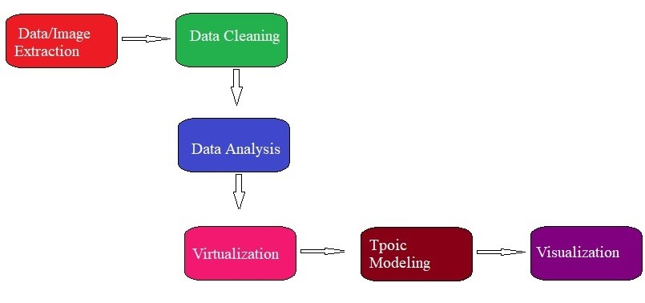

FIGURE 2.1: Phases of the Project

Chapter 3

LITERATURE SURVEY AND

REVIEW

#### 3.1 Literature Collection & Segregation

3.1.1 Introduction:

As the research and analysis from the sources show that, the number of road accidents are in rise day-by-day due to the negotiation of traffic rules. Data analysis is done to find out more details of the system.

In this paper [1], D. Doermann, J. Liang, H. Li set a framework to recognize the motorcyclists who are damaging the helmet laws, a framework utilizing picture handling and convolutional neural system is executed. The framework comprises of motorbike recognition, head protector versus no helmet grouping and motorbike number plate acknowledgment. The motorbikes are distinguished utilizing the element vector HOG. When the motorbike is recognized, by methods for convolutional neural system, it is resolved whether the motorcyclist is wearing a helmet or not. In the event that the motorcyclist is distinguished without helmet at that point the tag of the cruiser is recognized utilizing tesseract OCR.

In this paper [2] Jian Liang, David Doermann, discussed about the availability of high performance and low-priced digital imaging has created a tremendous opportunity for traditional screening for document image. cameras attached traditional scanner-based camera-based document analytics provide us with a good reference but they cannot be directly on camera captured images. They present a survey of application domains, technical challenges, and solutions for the analysis of documents captured by digital cameras.

In this work [3] Record picture recovery is a strategy utilized for looking through unsorted pictures of archives to locate the ones which are applicable for a given errand. In the previous barely any year’s workplaces and associations kept up their reports in printed structure, as the volume of printed archives were expanded, they experienced issues like space to keep them also, looking of specific archive. Printed reports are filtered trying to move towards a paperless office and are put away as pictures. Because of the advances in data innovation and monetary attainability of making a huge database of report picture has left a colossal requirement for vigorous approaches to get to the data. Numerous procedures have been created to give a proficient and powerful route for recovering and arranging these report pictures in the writing.

In this work, [4] a Non-Helmet Rider discovery framework is constructed which endeavours to fulfil the robotizing of recognizing the criminal traffic offense of not wearing protective helmet and removing the vehicles number. The fundamental rule included is Object Detection utilizing Deep Learning at three levels. The articles distinguished are individual, cruiser/sulked from the start level utilizing YOLOv2, protective cap at second level utilizing YOLOv3, License plate at the last level utilizing YOLOv2. At that point the number enrolment is extricated utilizing OCR (Optical Character Acknowledgment). Every one of these procedures are exposed to predefined conditions and limitations, particularly the tag number extraction part. Since, this work accepts video as its info, the speed of execution is significant. We have utilized above said procedures to construct an all-encompassing framework for both cap recognition and licence plate number extraction.

In this work [5] Henry S. Baird stated some spurred by the material science of picture arrangement and others by the surface measurements of picture appropriations. A wide scope of strategies for evaluating parameters of these models has been investigated. These models, as pseudo-arbitrary generators of engineered pictures, license, for the rest time, examinations concerning crucial properties of solid picture acknowledgment issues including the Bayes blunder of issues and the asymptotic precision and space of competency of classier innovations. The utilization of huge arrangements of manufactured pictures, in the development and testing of elite classier, has quickened over the most recent couple of years. Open issues incorporate the inquiry for strategies for looking at contending models and sound approaches for the utilization of manufactured information in designing.

In this paper [6] Tunku Abdul Rahman need to introduce a programming device made for recognition. So as to show the usefulness a study case was pick. In this investigation case a vehicle is distinguished by its tag. The fundamental thought is basic yet the complexities of pragmatic usage force a deliberate approach. This is on the grounds that a basic thing can be found in numerous structures. Likewise, the condition of the number plate (because of climate conditions or harms or devaluation make another scene without fail. From this scene a basic zone must be utilized. The device will perceive this specific region and will process just the applicable data. In the second step of the procedure the product apparatus will attempt to perceive the characters or digits that make the picture. In the following step the data is changed in computerized object so as to perceive the number in the database. In the paper we present the supporting ideas as” PC vision” and picture preparing”.

In this paper [7] traffic rules and common issues are discussed These are not efficient because it does not have evidences or proofs to take a proper action. People nowadays are not tend to drive safe. There are violations such as over speeding, red-light violation and overtaking another vehicle on single- and double-line violations. In this system a framework to identify who breaks the rules will be detected and take actions according to the rule that has broken. To identify them, image processing technologies, tools and hardware tools such as ultrasonic sensors, raspberry-pi pc and cameras will be used. A key benefit of this system is that it can reduce the number of road violations that can happen and people will be afraid to violate rules because of the automated system.

Prutha Y.M and Anuradha S.G [8] has developed a system for morphological image processing approach of vehicle detection for real-time traffic analysis. Morphological operations and image processing techniques such as background subtraction are used for detecting moving and non-moving objects on the roads. Edge detection operators such as Prewitt, Boolean, sobel operators are considered as key importance. The objects in the image are converted into Gray-scale image for easy identification, as such done in our project.

In this paper [9] To distinguish them, picture handling innovations, apparatuses and equipment instruments, for example, ultrasonic sensors, raspberry-pi pc and cameras will be utilized. A key advantage of this framework is that it can lessen the quantity of street infringement that can occur and individuals will be hesitant to disregard rules as a result of the robotized framework. The frameworks at present accessible doesn’t bolster all the highlights, this framework will cover red light infringement, over-speeding and vehicle overwhelming infringement just as this framework will utilize methods, for example, foundation deduction, object following and ultrasonic sensors. ”VirtualPolice” framework endeavours to result dependable and progressively proficient contrasting with frameworks that are accessible. This framework is intended to gather confirmations of the infringement and take activities as needs be. At the point when an infringement is refreshed the framework is modified to advise closest police officers android gadgets.

Amey Narkhede, Vikrant Nikam, Akshay Soni and Abhishek Sathe [10] proposed an ANPR for recognising traffic violators. In this paper they used Arduino based system and IR sensors. Edge detection method is used for identifying the number plate of a vehicle. As character reading is sensitive to misalignments and to different to different sizes, transformations is not carried out properly in this system.

O. Martinsky, [11] in his thesis has given a complete process of extracting or reading characters from the image. In the thesis he has given the detailed mathematical concepts on machine learning and artificial intelligence algorithms which are used for recognizing the license plate using Edge detection and rank filtering method and reading character using binary score and weighted score. He has used Heuristics and feature extraction techniques for horizontal and vertical image detection. The concept of priority analysis is also used which helps in selection of vehicles by the type of number plate or material. McCulloch-Pitts binary threshold neuron, which is a part in CNN is also the concept used by O. Martinsky.

Nourdine Aliane, Javier Fernandez, Mario Mata and Sergio Bemposta [12] in their paper described the framework and components for providing feedback for drivers who violate the traffic rules. In this paper, an accurate and efficient road boundaries and vehicle boundaries are detected. It combines Hough Transform and Canny Edge detector, Least-square method and Kalman filter to minimize the adaptive region of interest. The major drawback is due to the sensor behaviours, real time processing is delayed.

C. Vishnu, Dinesh Singh, C. Krishna Mohan and Sobhan Babu [13] developed a system for detecting vehicles without helmets from the Videos. They adopted background subtraction method to get moving objects. CNN is applied on the frames to select motorcyclists among the moving objects. Deep learning used for training dataset improves the detection rate and reduces fake alarms.

Emy Barnabas and Amritha B.J [14], designed a system for the automatic detection of motorcyclists who are not wearing helmets. They used SVM classifier to train the features from the images by considering the upper part of the image. This method has lots of misinformation’s in it, as it does not identify the vehicle first. CNN algorithm is used to classify the helmets and non-helmets. CNN takes the common hidden features in the set of trained data and detects helmet.

In [15] used Edge detection technique for identifying the shape and size of the objects. This paper has a survey on methods that use digital image processing techniques to detect objects the digital images. Identification of size of each object is an important and time taken task in this system. Reading images from digitals image is a major task. Helmet is one of the fundamental insurance unit for a motorcyclist. In any case, many neglects to comply with the law of wearing protective helmet

R. Handaric and D. Floroian [16] has given few supporting concepts through which we can read the characters from an image using OCR technique. They have designed a software program tool using C++ and OpenCV library. The overall concept of this paper is image recognition. The shortcomings of this paper is their research is based only on the colour of the car number plates and the data is not properly trained.

#### 3.2 Critical Review of Literature

This plans to propose for identification of motorcyclist without helmet. For this, we have applied various algorithms after the research to remove the noise in the picture traits. At that point, the Multilayer Perceptron classifier was utilized and the got outcomes were contrasted and others calculations. Pictures of vehicles in the traffic were caught by cameras from open streets and establish a database of 255 pictures. For sure, the calculation step with respect to the head protector location achieved an exactness pace of 91.37 percent.

This writing survey concentrates on three key research. These incorporated an analysis of literature describing the attributes of genuine situation, a basic survey of current guidelines and an audit of the edge detection criteria is done. The final writing audit gives an outline of the hypothesis of head protector discovery. The ALPR assumes a significant job which are related to these issues as its application ranges from controlling traffic to avoiding accidents and collisions.

This paper presents a methodology for Number Plate Recognition (NPR) utilizing morphological activity and Canny edge identification technique. Right now, the letters and numbers utilized in the number plate are sectioned by utilizing bouncing box strategy. After division, format coordinating methodology is utilized to perceive numbers and characters. The number plate decoded can be utilized further for distinguishing proof, coordinating and documentation reason for vehicle details. Edge location as a prelanding stage is a major and significant part of the number plate extraction framework. This is because of the way that the distinguishing proof of a specific vehicle is reachable utilizing the number pl ate on the grounds that each number plate is one of a kind to a vehicle. Thus, the characters of a number plate framework that contrast in lines and shapes can be separated utilizing the rule of edge discovery. This paper presents a strategy for number plate extraction utilizing edge recognition method. Edges in number plates are related to changes in the power of pixel esteems. Along these lines, these edges are distinguished utilizing a solitary based pixel or assortment of pixel-based methodology. The effectiveness of these methodologies of edge discovery calculations in number plate extraction in both boisterous and clean condition are tested.

Chapter 4

ACTUAL WORK

#### 4.1 Methodology for the Study

4.1.1 Introducing Framework:

OpenCV:

OpenCV is developed by Intel and is supported by Willow Garage. It is a huge opensource computer vision library. OpenCV-python is a Python API which focuses mainly on computer vision, image processing and machine learning. It is free for use under BSD open source license and the library is a cross-platform. It mainly focuses on the real-time image processing. OpenCV can process videos and images from the surveillance camera with the technique of image processing. The figure 4.1 is the logo of OpenCV.



FIGURE 4.1: OpenCV

Why OpenCV?

OpenCV used for Computer vision. OpenCV can be preferred over MATLAB due to various reasons. Each function of OpenCV is designed with the Image Processing coder in mind. On the other hand, MATLAB is quite generic. OpenCV has all the forms of toolboxes. Starting from financial tool boxes to highly specialized DNA toolboxes. MATLAB is very slow. MATLAB is built with Java. Hence, running Matlab program when the computer is busy, interrupts all the Matlab code. Finally, it turns it into Java, and the code executes. Matlab uses too much system resources. OpenCV will require as little as 10mb RAM for a Realtime application.

Tensor Flow:

Tensor Flow is a backend library support for building CNN. It is a Google’s open source for dataflow programming across various tasks. Tensors are represented as multidimensional Data arrays. The framework consists of nodes. The nodes within the graph represents mathematical operations, and the graph edges represent the multi-dimensional tensors. Tensors are the extensions of 2-dimentional tables of data with higher dimensions. Tensor Flow has many features which makes it appropriate for Deep Learning. YOLO algorithm is one of the algorithms that TensorFlow supports in object detection.

The below figure 4.2 is the design of TensorFlow.



FIGURE 4.2: TensorFlow

4.1.2 System Requirements:

1. Python version-3.5
2. Camera that captures images.
3. Memory- Sufficient memory for keeping and modifying the program source files and dataset files.
4. An Operating system which supports and provides an environment to support OpenCV and its components.
5. Required libraries for the support.

The main objective of the work is to perform various operations on the image that is captured. To achieve this objective Machine Learning algorithm is used on the image by using predefined resources.

1. A thorough study of existing techniques and libraries for performing data analysis in python.
2. Collection of images from the camera (from roads, parking lots etc.).
3. Extraction of details (data) of vehicles.
4. Pre-processing of the data collected is performed so that it can be used for analysis.
5. Checking for the violation of traffic rules.
6. Storing the data in the relevant data frames for future verifications.

Since the PC is simply one bitmap made up of thousands of individual pixels, when we scan the document and then open it in a word processor we cannot edit or alter it in any way. However, software has been replaced overtime. A freebie with scanners that can convert these groups of pixels into characters are available nowadays. This is OCR technique, which scans each group of pixels estimates each letter and replaces the same with the pixels with the ASCII code for each letter. This software associated with OCR scans the whole document and produces a page of letters and it can be edited.

OCR is the fundamental technology that is used in ALPR and provides the capability of storing and sorting of data. ALPR cameras are special type and set up within certain important parameters like distance, crowd etc.

When the vehicle approaches the camera, the software takes continuous snapshots and stores them in a file. When the license plate is of exact size for the OCR software, the frame is scanned and the registration number is converted into ASCII code and held in a list. According to the speed and position of the vehicle series of images. The list is then scanned for similarities and one image is selected to retain. 10-15 images would be scanned by the system, out of which 5 of them is considered the minimum for high accuracy. The next step is the start of ALPR capturing and this is totally dependent on the correct set up OS camera, lens, illumination, angle of view and configuration. At a particular stage, we only concentrate on the number plate capture, but there are many more aspects to be considered for a complete integrated system.

#### 4.2 Experimental and/or Analytical Work Completed in the Project

Since the PC is simply one bitmap made up of thousands of individual pixels, when we scan the document and then open it in a word processor we cannot edit or alter it in any way. However, software has been replaced overtime. A freebie with scanners that can convert these groups of pixels into characters are available nowadays. This is OCR technique, which scans each group of pixels estimates each letter and replaces the same with the pixels with the ASCII code for each letter. This software associated with OCR scans the whole document and produces a page of letters and it can be edited.

OCR is the fundamental technology that is used in ALPR and provides the capability of storing and sorting of data. ALPR cameras are special type and set up within certain important parameters like distance, crowd etc.

When the vehicle approaches the camera, the software takes continuous snapshots and stores them in a file. When the license plate is of exact size for the OCR software, the frame is scanned and the registration number is converted into ASCII code and held in a list. According to the speed and position of the vehicle series of images. The list is then scanned for similarities and one image is selected to retain. 10-15 images would be scanned by the system, out of which 5 of them is considered the minimum for high accuracy. The next step is the start of ALPR capturing and this is totally dependent on the correct set up os camera, lens, illumination, angle of view and configuration. At a particular stage, we only concentrate on the number plate capture, but there are many more aspects to be considered for a complete integrated system.

4.2.1 Python Environment:

Python has multiple programming languages and has various interpretations. Software has to be created such that it has to run on a particular version of the language because software assumes a certain behaviour which is present in old version but changes in new version. This is where virtual environments are used.

There are many ways to create an environment, including using virtualenv, venv (built in to the Python 3 standard library), conda and OpenCV, the package manager associated with Anaconda.

4.2.2 Camera Positioning:

The positioning of the camera is the most important part of the project for satisfactory operation of an ALPR system. The positioning can vary the percentage of recognitions to number of vehicles from 30-40 percentage to near on 100 percentage. The location of the camera depends on various factors mentioned below:

1. Single camera covering a barrier entrance:

This is the best position for a camera and illuminator in a 1M high bollard viewing directly at the vehicle which is approachable.

1. Single camera covering one line:

This position is the pole mounted unit about from 18M to 30M from the vehicle.

1. Multiple or single camera(s) covering multiple lanes:

This type is a special application requiring input from the ALPR provider.

1. Town centre cameras already installed:

The cameras usually are installed for manual monitoring of vehicles, and will not have installed ALPR in it and so the positioning will not be optimized, they will generally be colour with no infrared illumination and will be automatically operating with the shutter speed set to 1/50th.

Firstly, the shutter speed of the camera is to be adjusted. Setting the shutter speed remotely would be the best, else each camera needs to be monitored by human and setup the shutter speed manually. 1/1000th is the optimum setting for a normal camera. Alternative settings may vary from 1/250th for traffic up to 5MPH and 1/500th for traffic upto 40MPH.

We also have to consider that the camera positions and heights would not be at

the optimum for ALPR. Special attention must be paid to the angles of skew and rotation and a guaranty obtained an acceptable percentage of recognitions will be achieved.

1. Cameras on motorway bridges:

This again needs a special application which requires input from the provider.

1. Congestion charging cameras:

Before starting, this application requires the input from the ALPR provider and the local authority.

1. Cameras in Police vehicles:

These are the colour cameras mounted on a swirl mount and can view images either to the front or on sides of the vehicles. This also requires the input from the provider.

4.2.3 Libraries:

In programming, a library is a cluster or pre-configured selection of functions, operations, and routines that a program can regularly uses. These elements are generally assigned as modules/files, and stored in object format.

Libraries are important, because you load a module and take advantage of everything it offers without principally associating to every program that relies on them. They are truly standalone, so that you can own programs with them.

NLTK-Module:

Natural Language processing with Python NLTK is used for Natural Language Processing. It is one of the popular platforms for working with human language data and python. It provides easy-to-use interfaces along with a suite of text processing libraries for classifications, stemming, tokenization, parsing, wrappers, tagging and semantic reasoning for industrial strength NLP libraries.

Requests:

Requests is a library used by humans to send HTTPS requests to the main server. It is an Apache library where humans use it to interact with the programming language.

Requests help to grant access to the response data.

Beautiful-Soup:

Beautiful Soup is also a library that works with the parser to help in searching, navigating and modifying the parse tree in the framework. The library is also used in abstracting the text from HTML, and XML files.

NumPy:

NumPy produces high performance multi-dimensional array object. It is a generalpurpose array processing manager. It also provides tools for working with those multidimensional arrays.

MatPlot:

MatPlot has module named pyPlot which helps in plotting 2D graphs by providing feature to control font properties, formatting axes and line styles etc. It supports a very broad collection of graphs and plots namely - bar charts, histogram, error charts, power spectra etc. It is used along with NumPy to provide an environment.

Web-browser:

The web browser module in python provides an interface to display web-based documents.

Pandas:

Pandas is built on NumPy package and is a high-level data manipulation tool. Its key data structure is called Data Frame which allow you to store and manipulate tabular data in columns of variables and rows of observations.

#### 4.3 Modeling, Analysis & Design

4.3.1 Proposed Architecture:

To design and develop a real-time application, detection, tracking and license plate recognition system that will work efficiently under the conditions of slow moving objects and those objects are to be merged into the background due to a temporary stop and becoming foreground again, adaptive to different traffic environment conditions, robustness against progressive or sudden illumination changes, identifications time of the systems should be as short as possible. The figure 4.3 is the basic structure of the project.

The various modules involved in the projects are as follows:

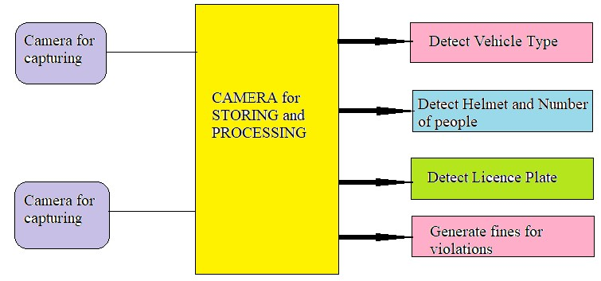

FIGURE 4.3: Architecture

Module 1- Detection and Segmentation of vehicles:

Detecting the objects from the captured images is an important part in the project. Identifying movable and non-movable objects from the images is done in this phase.

Segmentation is the further step which segregates motorbikes from other objects or other vehicle on the road.

Below are the steps of how motorbikes are identified and segregated.

* Pre-processing on the captured images

Pre-processing is the first and most important step in the processing of captured image. The image is scanned which further is checked for noise, skew, slant etc. Possibilities of getting skewed image with either left or right orientation or with noise such as Gaussian is higher. Hence, the image is first converted into grayscale and then into binary. This way we get the image which is suitable for further processing.

* Segmentation

The noise-free image which we get after pre-processing is passed to the segmentation phase. Here the image is decomposed into individual binary characters. The binarized image is then checked for inter-line spaces. If the lines are found, then the image is segmented into sets of paragraphs across the interline gap. Horizontal space intersection with respect to the background are scanned in the lines of the paragraphs. Then the words are decomposed into characters with the help of character width computation.

* Feature extraction

Segmentation phase of OCR is followed by feature extraction, where the individual image is considered and extracted for features. Each character glyph is defined by the attributed such as height and width of the characters.

* Classification and Post-processing

Feature extracted character glyph are used in classification. Labelling to different classes are features to be analysed with the help of the set of rules.

The figure 4.4 is the flow diagram of how the segmentation is done for further distinguition.

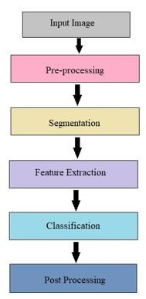

FIGURE 4.4: Segmentation of Vehicles

Algorithm 1

1: Start

2: Capture and scan the image

3: Pre-process to remove noise

4: Load the database

5: Perform segmentation and classify the lines

Module 2- Identifying Motorcyclists without Helmet: Riding without helmets is a huge ofense and leads to major damage to the motorcyclists when met with an accident. Hence, identifying the motorcyclists without helmets is an important module in the project. Object detection is the major process while identifying the helmets. The steps are given below:

* Background Modelling

After identification of the vehicle by following the steps mentioned in the previous module, the next step is Background Subtraction. Gaussian mixture model is applied on each pixel.

* Object Detection

YOLO framework deals with the object detection ia a unique way. The entire image is taken into picture and it predicts the boundary box coordinates and class probabilities for these boxes. YOLO is very fast and can process 45 frames per second.

* Object Classification

CNN algorithm has the ability to extract inter-dependant information from the images, that is, localization of the pixels which are highly sensitive than other pixels. It obtains high-level features from the spatial data like images.

Canny-edge detection is used to identify the shape of the objects. Here this method is used to extract details of number of people by detecting the edges.

* Identifying Motorcyclists without Helmets:

From the selected image, in order to identify motorcyclists without helmets, top 1/4th part of the image is cropped as that is the region where the motorcyclist’s head is located most of the time. Binary subtraction is applied in the foreground for the same. Then CNN-model is built to separate the with-helmet from the without-helmet images.

The figure 4.5 is the step by step procedure which is used to detect helmet using CNN algorithm.

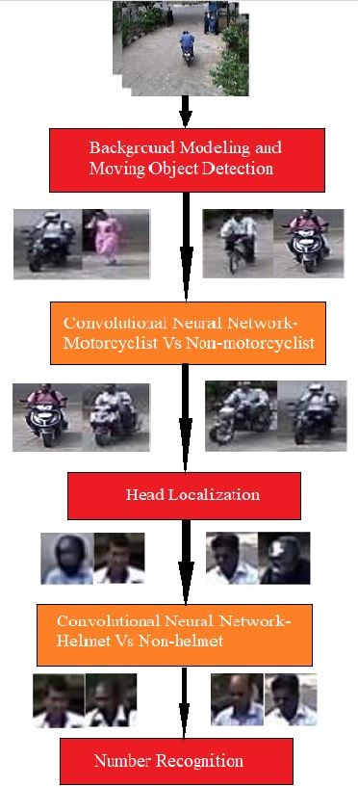

FIGURE 4.5: Helmet Detection

Module 3- Signal Breaking detection:

* For the detection of signal breaking the difference in the image is noted. in the difference image if all the pixels including the white are considered. This decides that there is a occlusion and if any pixel is found black then it means that there is a violation of traffic rules.

Module 4- Detection and Extraction of Numbers from License Plate:

After identifying the vehicles that violate traffic rules, detection of license plate is done. In this module identifying the license plate and extracting the characters from the plate is done.

The process of how the text is generated from the image captured is shown in the figure

4.6.

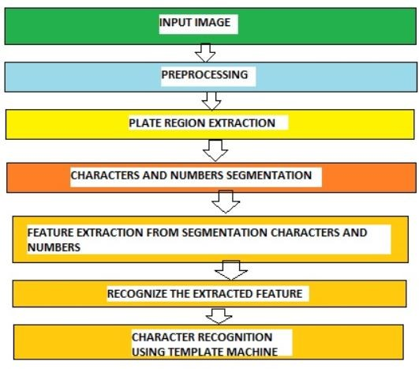

FIGURE 4.6: Extraction of Number Plate Details

* Edge Detection Canny Edge detection is a feature extraction technique for detecting the edges of the object. Here, edges of the license plate is detected for the pre-processing. Compared to Sobel edge detection, the Canny Edge Detection algorithm has the ability to detect maximum number of edges. It gives good results for detecting horizontal and vertical edges and also it can detect the circular edges and the edges in the corner.
* Text Detection

Input image or video is loaded into the database. This phase decides whether the image contains text or not.

* Text Localization

In the phase text regions are merged to formulate the text objects and defines the tight bounds around the text objects.

* Text Binarization

In this phase segmentation of the text object from the background in the bounded text objects is done. Input image is converted into binary image, where the text pixels and background pixels appear as two different binary levels.

* Character Recognition

This is the last phase where binary text is converted into ASCII text (readable text).

* Template Matching

The character extracted from the image is compared to the ones stored in the database and produces the best results.

* Priority selection and analysis
  1. Detect the candidates.
  2. Arrange them according to their cost of fines.
  3. Cut the first plate from the list with that of the best cost.
  4. Segment and find it by a deep analysis, with time.
  5. If the deep analysis refuses the plate, then do to back to previous step.
     1. Data Extraction:

In the whole process of the project, python is running on OpenCV and TensorFlow to connect with the web servers. Captured images are extracted in the form of snaps and the datasets. These are stored separately. The datasets are gathered from different sources using the requests library in Python.

The response data is taken from request library and extracts data using OCR technique.

Beautiful Soup is used to extract the data. Later the title and data are stored separately.

* + 1. Data Cleaning:

The extracted data is pre-processed using NLTK with the help of datasets provided, which contains almost all the collected and required sentiments. The first step is to remove anything other than English letters, space and numbers. Then the whole data is converted into upper case or ASCII values. The next is to remove any unwanted characters like symbols or any stickers.

Then the pre-processed data is then analysed and characterized into different modules with the help of data sets using CNN and YOLO algorithm.

NLTK module is used to remove stop words and then removing punctuational marks, special characters, double letters, duplicate words then creating indexed list of values after the data is pre-processed.

* + 1. Data Analysis:

In this project Artificial intelligence is used to analyse the pre-processed data. The main idea behind the artificial intelligence is to automatically identify the motor-cyclists violating the traffic rules using the license plate. After feature extraction method, the algorithm judges who is violating the rules and how many times and how much fine the motorcyclist owes.

* + 1. Algorithms and Mathematical Concepts:

The overall process of the project of how the entire system works is shown in the figure

4.7.

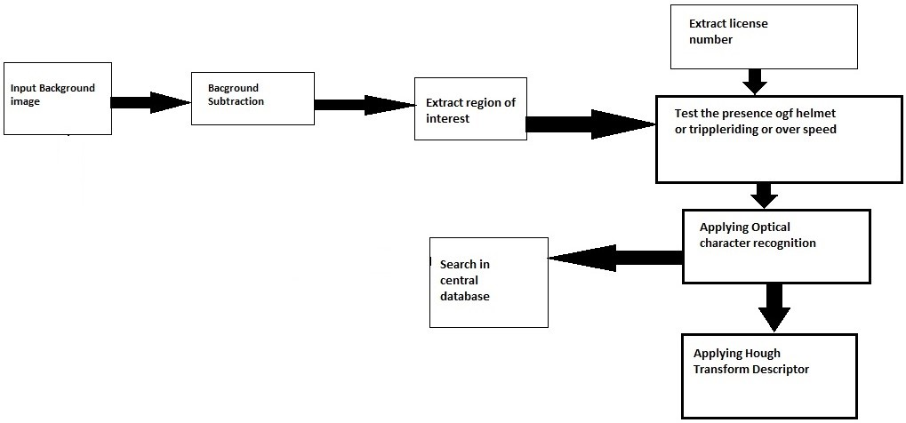

FIGURE 4.7: Overall Process

4.3.5.1 Background Subtraction:

The method is used to separate moving objects using Gaussian Blur.

Consider the intensity of a pixel as *I*1*,I*2*...It* where *t* is time of consecutive frames.

Then, the probability of observing intensity value for a pixel is:

*K*

*P*(*It*) = ∑*wtj**.* (4.1)

*j*=*i*

where, *wtj* is the weight, and *η* is Gaussian Probability density function, which has the mean value *µtj* and variance *σtj* at time *t*. The pixels with low variance and high weight correspond to background class, whereas, those with high variance correspond to foreground class. Pixel intensity *It* is checked with respect to time *t*. If *jth* component satisfy the below condition, then *jth* component is a match.

*t*

*j,* (4.2)

Pixels are classified as background or foreground accoring to the*jth* model. Here, the weight is given by:

*wtj 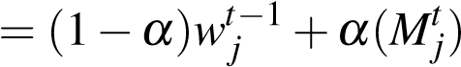,* (4.3)

where, *Mtj* = 0 for matched model, and *α* is learning rate which determines how frequently parameters are adjusted. The parameters for the matched models are as:

*µt* = (1−*ρ*)*mut*−1+*ρIt,* (4.4)

(*σ*2)*t* = (1−*ρ*)(*σ*2)(*t*−1)+*ρ*(*It* −*µt*)2 (4.5)

where, *ρ* = *µ*(*It*|*µj,σj*). A new guassian model with low pixel, low prior weight and high variance is created when there is no matched components. This model helps in creating new component if maximum number of components is reached. All the forground moving objects are resized and then given as input to a CNN classifier.

4.3.5.2 Gray Scale Conversion:

From the image each pixel (*i.j*) companents R, G and B are seperated and 8-bit gray value is found using:

*Gray*(*i.j*) = 0*.*59·*R*(*i.j*)+0*.*30·*G*(*i.j*)+011·*B*(*i.j*)*.* (4.6)

Here, we have used 3 × 3 masks to get 8 neighbors of a pixel and the corresponding gray values. This removes the noise and skews in the images.

For enhancing the contrast, total 256 numbers of gray levels from 0-255 are used. If the total pixels in the image are *N* and *nk* is the number of pixels having gray level *k*. The probability if gray level *k* occurance is *Pk* = *nk/N*. *Sk* is the stretched gray level which calculates the frequency of *k*.

*k*

*nj*

*Sk* = *j*∑=0 *N* ·255 (4.7)

The characters on the license plate are written in regular intervals with specific height and horizontally. The pattern of vertical edges also remain similar. Here, we find the license plate region within the image. The vertical edge at the point (*x.y*) is found by:

v

(

*y*

*,*

*x*

)=

u

u

t

[

+

1

∑

*m*

=

−

1

+

1

∑

*n*

=

−

1

*image*

*c*

*ont*

(

*y*

+

*n*

*,*

*x*

+

*m*

)

2

*gradM Mmask*(*n,m*)· ] (4.8)

4

where, *imagecont* is the enhanced image over which edge detection is applied, *Vmask* is the masked image and *gradM* is the vertical edge gradient.

The value of *gardM* used the threshold *µgradM* together formed the edge image *imgedge*.

The key factor for binarizing the edges is the thershold value.

Algorithm 2

1: Start

2: Receive the filtered image

3: RGB to Gray-scale conversion

4: for vehicle tracking from the image

5: if number of motorbikes¿ threshold Print traffic is heavy; Else, print the number of frames in the video.

6: Go to 4 End

4.3.5.3 CNN:

CNN is one of the Pattern Recognition Techniques, which enables to classify the patterns according to the classes. The architecture of neural networks has the similar functionality and structure as that of the biological neuron (neurons in human brain). The mechanism of neural network of human brain is to alter the “Weights” of the connections of axons and terminals from one cell to another. “Weight” is the representation of the behavior of connection of neurons. Scientist McCulloch-Pitts proposed a mathematical model for identifying the object patterns. Binary Threshold Neuron is the name given to the model. The figure 4.8 is the schematic representation of Neural cell of the Human brain.

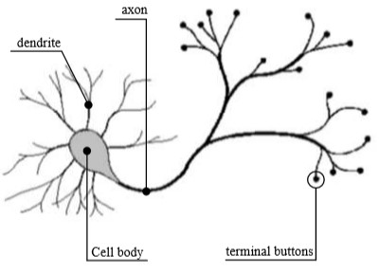

FIGURE 4.8: Schematic representation of Human Neural Cell

The threshold neuron also has only to possible output values (0 or 1) and only two types of synaptic weights- Fully excitative and the fully inhibitive. The excitative weight has positive value 1, and does not affect the input, whereas, the inhibitive one has -1 value and affects the input.

The weighted inputs are summed up together and processed by a neuron as given below; Let *x*0*...xj*−1 be the inputs with weights *wi,*0*...wi,j*−1 respectively. *J*−1

|  |  |
| --- | --- |
| *y* = *g*(∑ *wi,j* ·*xj* −*µ*1);  *j*=0 | (4.9) |

*g*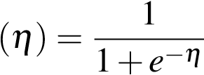 (4.10)

Where, *g*(*η*) is a sigmoid function (4.9) and *µi* is a threshold value.

The figure 4.9 represents the summation and the gain functions which has thershold in it and a dedicated input.

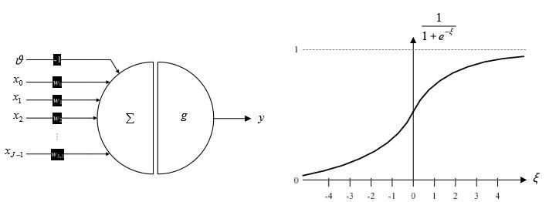

FIGURE 4.9: The summation and gain function of the perception

According to the Kolmogorov’s theorem, there exists a function *F* : *Rm* −− *> Ro* in a multi-layered neural network. The function grows continuously in the interval gap of 0 to 1. The equation of function *f* is written as:

2−*m m*−1 *f*(*x*0*...xm*−1) = ∑*αi*( ∑*φj*(*xj*)) (4.11)

*i*=0 *j*=0

Where *αi* are continuous functions with single parameter.

The neural networks consists of two layers; One is the hidden layer and the other is the output layer. Within a single layer, there is no connections or feedback between the neurons; whereas feedback is sent between adjacent neurons.

|  |  |
| --- | --- |
| *zi* = *g*( ∑ (1)*i,jx*˙*j* −*µi*)  *j*=0 | (4.12) |
| *n*−1 *yi* = *g*(∑ (1)*wi,jz*˙*j* −*µi*) | (4.13) |

*m*

*j*=0

The equation 4.12 shows the activities of neurons in the hidden layer and the equation

4.13 shows the activities of neurons in the output layer.

4.3.5.4 Edge Detection:

Canny Edge Detector is considered to be one of the most optimal edge detector. It satisfies all the below mentioned criteria.

1. Filtering any disturbances in the image by using a Guassian Blur operator.
2. Locating the edge strength in the smoothened image by computing the image gradient , which helps to detect where exactly is the edge located.
3. To thin down the image edges by tracking along the direction of edges and setting pixels that are not at the max. 0 (non-maximum suppression). If the magnitude is high it is considered as an edge. If the magnitude is low, it is not considered as an edge.

This detection method is the simplest extention of the ideal step edge model for modelling blured edges. Periodical concolution of the function *f* is used with specific types of matrices m to detect edges in an images:

*w*−1 *h*−1

*f* 0(*x,y*) = *f*(*x,y*)∗*m*[*x,y*] = ∑ *x* ∑ *yf*(*x,y*)∗*m*[*mod*(*x*−*i*)*,mod*(*y*− *j*)]; (4.14)

*i*=0 *j*=0

where, h and w are the dimensions of the image which is represented by the function f.

4.3.5.5 Heuristic Analysis and Priority Selection:

The images those are captured usually consists of numerous license plates. Priority selection helps in sorting the number plates according to the time of image captured. This is done by taking predefined value of maximum number of plates.

Several heuristics mentioned in the table 4.1 are used to detect the cost of selected owners of vehicles. This sorts the owners according to the cost, from highest to the lowest. Here, Deep Learning come into picture. Deeper analysis accepts or rejects the owners.

Cost is the basic thing to be analyzed and evaluated, and then sort them according to this cost *αi*. The overall weights are computed as: TABLE 4.1: Priority Analysis.

|  |  |
| --- | --- |
| Heuristics | Description |
| *α*1 = |*yb*0−*yb*1| | Pixels are used to measure the band height. Lower heights bands are preffered. |
| *α*2 = *py*(1*ybm*) | The maximum value of peak of vertical projection is *py*(*ybm*) . Usually vertical edge bands of higher amount are preffered. |
| *α*3 = *y* 1 | It considers both the values of the greatest peak and area under the points. |
|  | The proportions of the 1-row lisence plates are similar in most of the countries. Hence height is compared. |

*α* = 0*.*15·*α*1+0*.*25·*α*2+0*.*4·*α*3+0*.*4·*α*4 (4.15)

Deep Analysis: The deeper analysis helps to find the the validity of a owenr of the license plate. The plate must be sorted in individual characters to gather the information.

Assume *wi* as width of character i, then the segmented characters *p*0*...pn*−1 generates the heuristics as below:

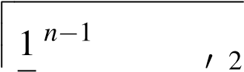 (4.16)

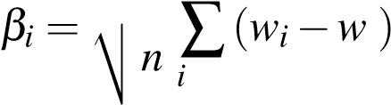=0

here, w’ is an average of caharcter width. *w*0 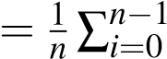*wi*

4.3.5.6 OCR:

OCR is applied after converting image into gray scale by eliminating the hue and saturation and retaining the intensity, detecting the edges and finally preprocessing the characters on the number plate.

OCR divides the image into rows and columns into a proper order. Inprder to divode the image into symbols, we used the following algorithm:

1. Divide the image into a set of maximal columns, *C*.
2. for each column *c* in *C*;

Divide *c* into set, *R*, of maximal rows.

For each row *r* in *R*, divide *r* into clumps. *S*.

Below is the mathematical expression for dividing images into rows and columns:

*n*

(*x*+*a*)*n* = ∑(*n,k*)*xkan*−*k*; (4.17)

*k*=0

Here, (*n,k*) represent the maximal valid rows of two central columns from *C*.

Representing the image in the single character is the main aim of the project. Hence, two matrices A and B of same size are taken to calculate 2-D correlation coefficient.

∑*mn* (*Amn* −*A*0)(*Bmn* −*B*0)

*r* =(4.18)

(*Amn* (*Bmn* −*B*0)2)

p

(

∑

*n*

*m*

−

*A*

0

)

2

)(

∑

*n*

*m*

Where A’ and B’ represent the mean values of A and B respectively. A and B are binary matrices. A set of template images must be saved for further application.

4.3.5.7 Feature Extraction:

The loop position of caharacters are defined by its centre. We must convert the rectangular coordinates of the element into polar coordinates to form the vector, using, normalized rectangular coordinates *x*0*andy*0 :

*y*0

*r* = p*x*02+*y*02;*θ* = *atg*(*x*0);*x*0 = 2·*xw*−*w*;*y*0 = 2·*yh*−*h* (4.19)

The below figure 4.10 is the skeleton of the character containing several structural elements. This helps to distinguish between the characters.

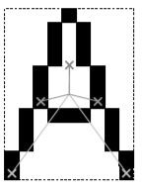

FIGURE 4.10: Rectangular coordinates

The image 4.11 is the layouts of regions in the character bitmap. The regions can overlap with each other.

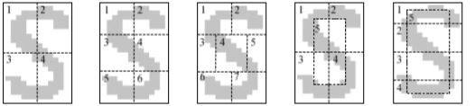

FIGURE 4.11: Character Bitmap

The length and structure of the vector may vary depending on the number and type os structural elements present in the character.

4.3.5.8 Character Identification:

To improve the recognition process, we have to assume some structural constraints in the table 4.2. More sophosticated solutions are occured with apative neural networks as shown in the figure 4.12.

TABLE 4.2: Structural Constraints

|  |  |  |
| --- | --- | --- |
| Line ends | Loops | Junctions |
| BDO08 | CEFGHIJKLMSTUVWXYZ  123457 | CDGIJLMNOSUVWZ  012357 |
| PQ69 | ADOPQR09 | EFKPQTXY469 |
| ACGIJLMNRSUVWZ  123457 | B8 | ABHR8 |
| EFTY |  |  |
| HKX |  |  |

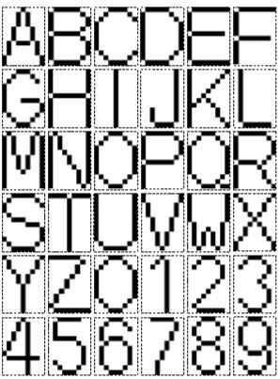

FIGURE 4.12: Skeleton alphabet

Chapter 5

RESULTS, DISCUSSIONS AND

CONCLUSIONS

#### 5.1 Results & Analysis 5.2 Epoch-wise results

# the training part

# we train for 64 epochs with about 100 steps each

History= model.fit.generator(traingenerator,

Steps-per-epoch=ntrain// batch-size

Epochs=64

Validation-data=val-generator

Validation-steps=nval// batch-size

1. We call the .flow( ) method on the data generators we created above passing in the data and label set.X-train and y-train for training then X-val and y-val for validation.The batch size tells the data generator to only take the specified batch(32 in our case) of Images at a time.
2. Now we train our network by calling .fit( ) method on the model and passing some parameters. The first parameter is the training set ImageDataGenerator object

[train-generator].

1. Here we specify the number of steps per epoch. This tells our model how many images we want to process before making a gradient update to our loss function.
2. A total of 3200 images divided by batch size of 32 will give us 100 steps. This means we going to make a total of 100 gradient update to our model in one pass through the entire training set.
3. An epoch is a full cycle or pass through the entire training set. In our case, an epoch is reached when we make 100 gradient updates as specified by our stepsper-epoch parameter.
4. Epochs = 64, means we want to go over our training data 64 times and each time we will make gradient updates 100 times.

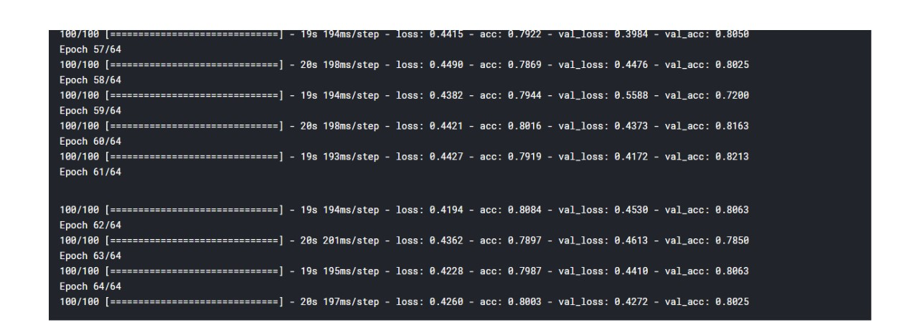

FIGURE 5.1: Training Dataset

The figure 5.1 is the result of training the dataset.

We have captured many snapshots of motorbikes for the test purposes. It is more useful to find the license plate of vehicles captured by an ALPR camera.

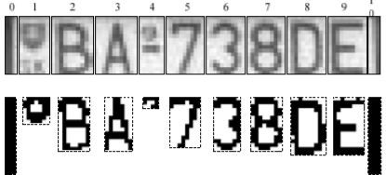

FIGURE 5.2: Extracting Characters

In figure 5.2 License plate number of the motorbike is extracted.

The characters are read from the sample number plate of the vehicle in figure 5.3.

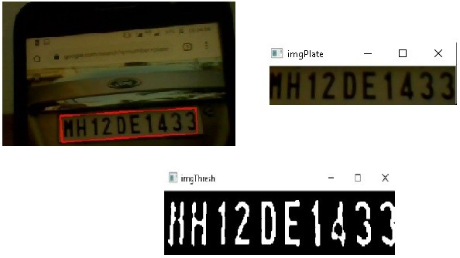

FIGURE 5.3: Reading characters of Number plate

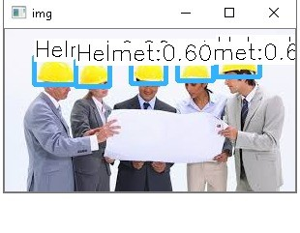

FIGURE 5.4: a. Random Helmet detection

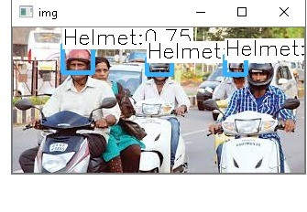

FIGURE 5.5: b. Helmet detection on motorbike

In figures 5.5 and 5.4 helmets are detected using YOLO algorithm, which help to detect objects. This is done after the image is converted into gray-scale.

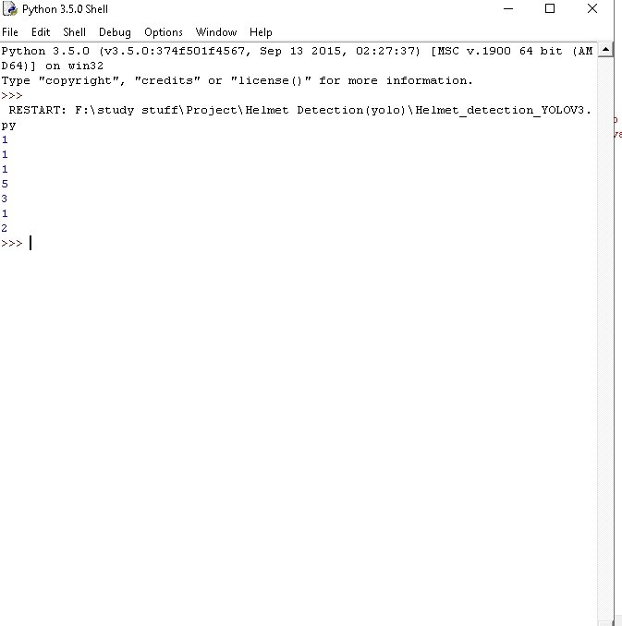

FIGURE 5.6: Preprocessing in YOLO Algorithm

In figure 5.6 the number of objects i.e, helmets are detected and further processed for preprocessing.

#### 5.3 Comparative Study

As increase in measure of data got from long range of surveillance camera stages it is difficult to manage whole datasets at a time. Sometimes it is difficult for a human to always monitor the whether motorcyclists are paying fine or not. Previously multiple manual methods were used to check on the traffic, which became difficult as the amount of data is increasing day-by-day. So, in order to automate the process virtual analysis is used to pre-process the data. In this Machine learning algorithms were used which can analyse the pre-processed images characterized into many parts for detection. Different types of classifiers are used to classify objects from one another and collect the datasets. YOLO algorithm and CNN algorithm are all sensitive to parameter optimization (i.e. different parameter selection can significantly change their output), So, the if you have a result showing that Algorithms are performing better, this is true only for the selected parameters. However, for another parameter selection. Convolutional neural network (CNN) and recurrent neural network (RNN), the two main types of DNN architectures, are widely explored to handle various NLP tasks. CNN is supposed to be good at extracting position-invariant features and RNN at modelling units in sequence. The state of the art on many NLP tasks often switches due to the battle between CNNs and RNNs. This work is the first systematic comparison of CNN and RNN on a wide range of representative NLP tasks, aiming to give basic guidance for DNN selection. For some datasets, with expansion using wrapper feature selection, for example, YOLO will be more desirable because of its high speed.

#### 5.4 Discussions

In proposed system pictures of both violators and non-violators of traffic rules are gathered together and license plate number is extracted only for the motorcyclists who violate the rules using various algorithms such as YOLO, OCR, CNN, and Canny Edge Detector and also Heuristic operator. In this the previously mentioned algorithms are used instead of SVM because those are probabilistic model and is independent of features of a given problem whereas SVM interacts with the features of the other models. In this AI techniques which is used to detect the topic of the given analyzed data. LDA is used because it is unsupervised learning techniquewhich does not need any classification indicator to classify the data. Sometimes, LDA also have classification indicator to classify the data.

#### 5.5 Cost Estimation Model

Cost Estimation is the approximation of the cost of a program or a project. The cost estimate is the cost of the product process including efforts and time. It is used to predict the quantity, cost, price of the resources required by the scope of the project. The project cost estimation includes the following parameters:

1. Time: The time for the completion of the project undergoing various phases ofimplementation is given in five months of time (approximately).
2. Efforts: Since the attributes of each project determine the distribution of efforts,40 percent of work is carried on analysis and design phases, 20 percent on testing phase and about 30 percent of the efforts on coding.
3. Cost: The cost of the project is assumed in terms of the resources used and efforts applied. The other parameters that account for cost estimation are: Man/MonthTechnology used -Benefits- Machine.

#### 5.6 Conclusions

In this project, the automatic number plate recognition system using the motor-bike license plate is presented. Various types image processing techniques are used in this system for identifying the vehicle from the database stored in the computer. The system satisfactorily works for wide variety of conditions and various types of number plates(public or private). OpenCV is used to implement and execute and performance is tested on genuine images.

The working of the system is quite good, however, there are improvements yet to be done. It is difficult for the camera to capture every image in hihgly populated roads as the shutter speed should bevibrant and fast changing. With high resolution camera we can improve the system speed. Affine transformation can be used to improve the character recognition of the bike lisence plate, as the present system for character recognition is sensitive to mis-alignment and to different sizes. For defining the probability of detection and recognition of the number plate, we can also use statistical analysis, which we can include in our future work. In the present system there are certain limitations on parameters such as speed of the vehicle, script/characters on the Lisence plate, noise and skew in the image which can be further enhanced by more effective algorithms.

#### 5.7 Scope for Future Work

As a future work the created framework would be concentrated upon expanding the exactness of content restriction and illustrations evacuation in subtitle content images. Today progresses innovation took Automatic Number Plate Recognition (ANPR) frameworks from hard to set up, constrained costly, fixed based applications to basic versatile ones in which ”point to shoot” technique can be utilized. This is conceivable due to the production of programming which ran on less expensive PC based and furthermore non authority equipment in which their no compelling reason to provide pre-characterized guidance, speed and size in which the plate would be passing the camera field of view. Likewise Smaller cameras which can peruse tags at fast, alongside littler, increasingly solid processors that can fit in police vehicles, permitted law authorization officials to watch day by day with the advantage of tag acknowledgment continuously. It very well may be assessed utilizing different other accessible picture information bases furthermore, utilizing different classifiers. The proposed strategies can be further done.

Second part, If they are not wearing the helmet, the tag of the cruiser is centered consequently. By utilizing Computer Vision method we can distinguish and perceive the tag number. We make the preparation set of various characters of various sizes.

Bibliography

1. D. Doermann, J. Liang, H. Li, *Progress in camera-based document image analysis*, Proc. of the 7th ICDAR, Page(s)606-616, 2003.
2. J. Liang, D. Doermann and H. Li, *Camera-based analysis of text and documents: a survey*, Int. Journ. onDocu. Anal. andRecog., vol. 7(2-3), Page(s) 84-104, 2005.
3. T. Kazutaka, K Koichi and I. Masakazu, *Real-Time Document Image Retrieval on a Smartphone*, IAPR International Workshop on Document Analysis Systems, DAS 2012.
4. T. Chattopadhyay, B. B. Chaudhuri, R. Jain, *, A Novel Low Complexity TV Video OCR System*, Int. Journ. onDocu. Anal. andRecog., vol. 7(2-3), Page(s) 84-104, 2005.
5. H. Tin Kam, H S Baird, *Perfect Metrics*, IAPR 2nd ICDAR, 1993.
6. *“Implementing Lane Departure Warning System on Raspberry Pi”*, University Tunku Abdul Rahman, May 2016, [Online] Available: www.eprints.utar.edu.my/ 1950/1/CN-2016-1308318-1.pdf [Accessed 20-JULY-2016].
7. *“A Real-Time Vision System for Night time Vehicle Detection and Traffic Surveillance”*, IEEE transactions on industrial electronics, Volume58, No-5, May 2011, [Online] Available: https://ir.nctu.edu.tw/bitstream/ 11536/8964/1/000289478000054.pdf [Accessed: 18-July2016].
8. *“Morphological Image Processing Approach of Vehicle Detection for RealTime Traffic Analysis”*, Science International Journal of Computer Science and Engineering, Volume-2, Issue-5, May 2014. [Online] Available: *http* : *//www.ijcseonline.org/pubpaper/IJCSE* − 00312*.pd f*[*Accessed* : 14 − *JULY* − 2016].
9. *“Development of an automated Red Light Violation Detection System (RLVDS) for Indian vehicles”,* , IEEE National Conference on Computing and Communication Systems, COCOSYS-09, CS11 [Online] Available:*https* : *//arxiv.org/ftp/arxiv/papers/*1003*/*1003*.*6052*.pd f*[*Accessed* : 14 − *JULY* − 2016]
10. Amey Narkhede , Vikrant Nikam and Akshay Soni, *Automatic Traffic Rule Violation Detection and Number Plate Recognition*, IJSTE - International Journal of Science Technology and Engineering — Volume 3 — Issue 09 — March 2017 ISSN (online): 2349-784X.
11. *“Algorithmic and Mathematical Principles of automatic Number Plate Recognition Systems”*,Ondrej Martinsky, BRNO University Of Technology, 2007.
12. Nourdine Aliane , Javier Fernandez , Mario Mata, Sergio Bemposta *A System for Traffic Violation Detection* , ISSN 1424-8220 www.mdpi.com/journal/sensors, 24 November 2014.
13. C. Vishnu, Dinesh Singh, C. Krishna Mohan and Sobhan Babu *Detection of Motorcyclists without Helmet in Videos using Convolutional Neural Network* , https://www.researchgate.net/publication/320797547 (Online), May 2017.
14. Emy Barnabas, AmrithaB.J *Helmet Detection and License Plate Recognition Using CNN* , IOSR Journal of Engineering (IOSRJEN) ISSN (e): 2250-3021, ISSN (p): 2278-8719 Vol. 09, Issue 6 (June. 2019).
15. A.Ushma, Prof. Dr. A.R. Mohamed Shanavas, *Object Detection In Image Processing Using Edge Detection Techniques* , IOSR Journal of Engineering (IOSRJEN) ISSN (e): 2250-3021, ISSN (p): 2278-8719 Vol. 04, Issue 03 (March. 2014).
16. R Handaric, D Floroian, *An Image Recognition Software tool For Car Identification Based On License Plate*, Bulletin of the Transilvania University of Bras¸ov Series I: Engineering Sciences • Vol. 5 (54) No. 1 - 2012.

50

Appendix A

Program Inclusion

A.1 Image Loading and Training:

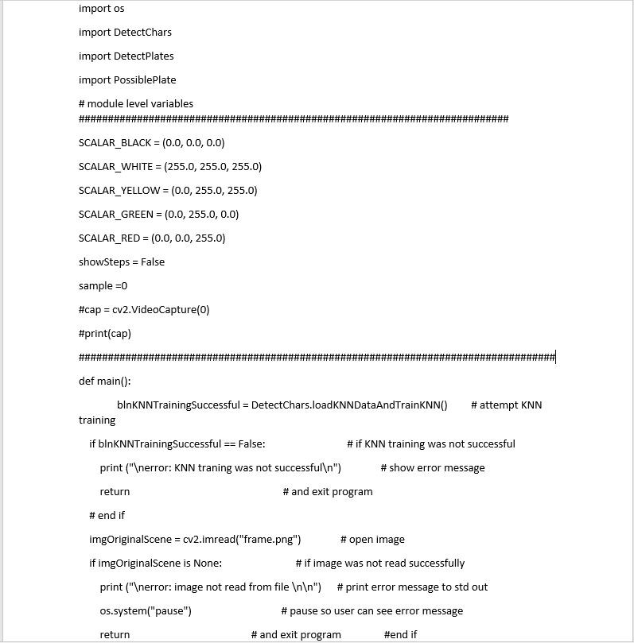

#### A.2 License Plate Number Detection

In this we wrote the code for reading the lisence plate number from the captured images of the vehicles.

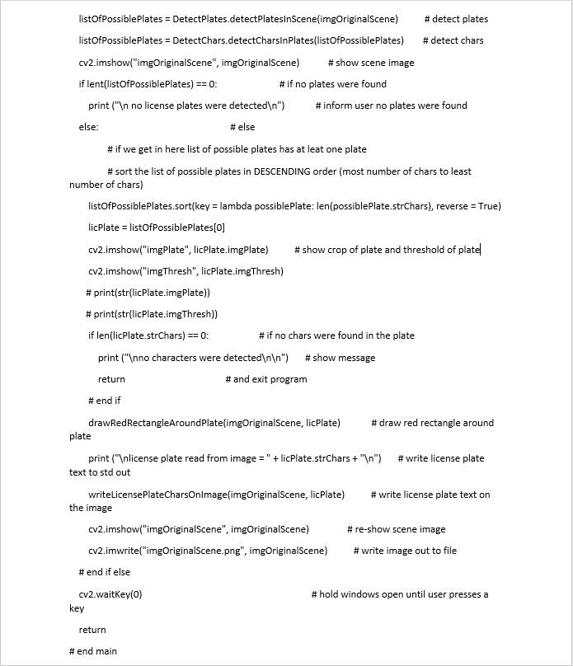

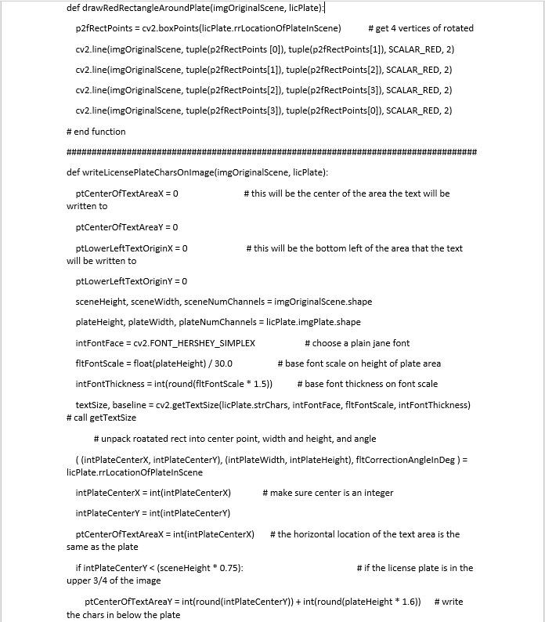

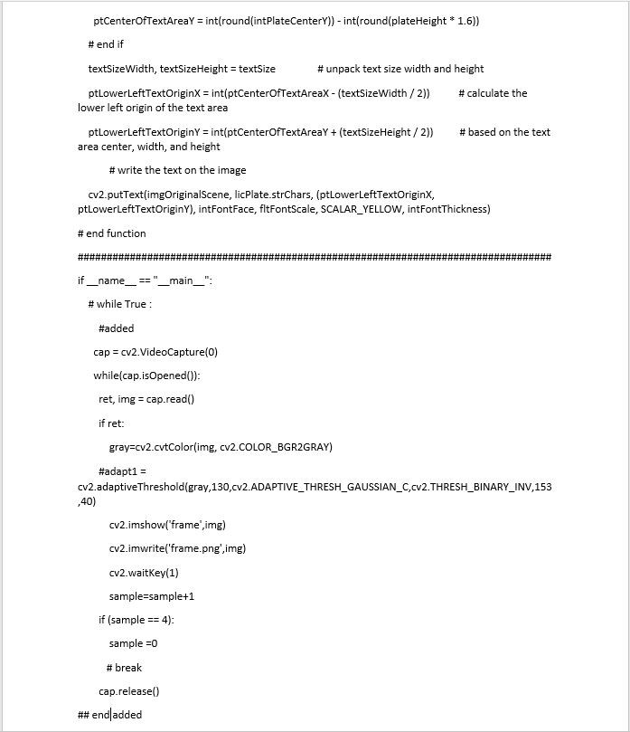

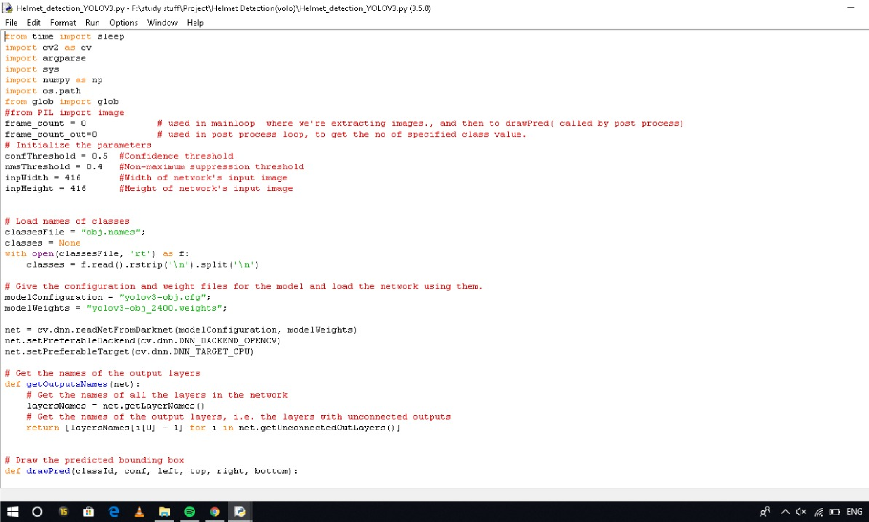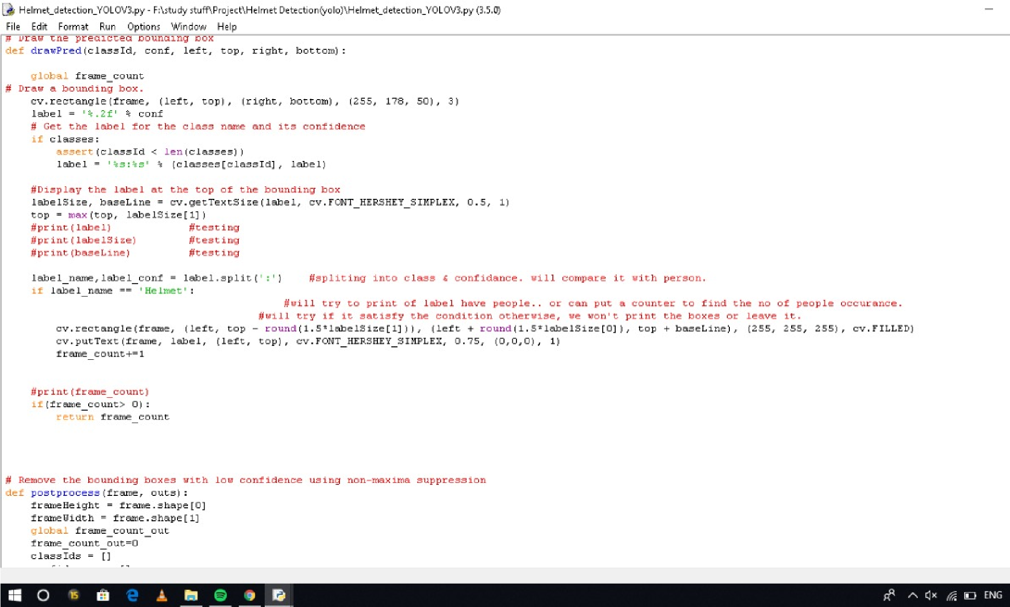A.3 Helmet Detection:

